20230310 計算機實習 Practice 04

**題目：**

請利用class幫忙設計一支簡易的學生系統

**題目要求**:

Class **Student**中需包含有以下元件(程式中必須使用此class 否則0分)

|  |  |  |  |
| --- | --- | --- | --- |
| 名稱 | 權限 | 型態 | 說明 |
| name | private | String | 學生名稱 |
| id | public | int | 學生id |
| dept | private | String | 學生科系 |
| getName | public | String function() | 回傳學生名稱 |

Class **Department**中需包含有以下元件(程式中必須使用此class 否則0分)

|  |  |  |  |
| --- | --- | --- | --- |
| 名稱 | 權限 | 型態 | 說明 |
| students | private | **Student**陣列 List<Student> | 科系中存在的學生 |
| name | private | String | 科系名稱 |
| addStudent() | public | void function (Student student) | 將student加入students的list中 |
| getStudents () | public | **Student**陣列 List<Student> | 回傳科系中的學生list |
| getTotalStudentsInDep | public | int function() | 回傳科系中的學生人數 |
| showDepStudents | public | Void function() | 印出該學系中的所有學生名稱 |

程式一開始於main中新增以下物件並於螢幕輸出"1.add student 2.show the number of students in a department 3.show all the students in a department 4.exit:"

**需新增的物件如下：Department CSIE, Department EE, Department MATH**

之後依據使用者的輸入執行不同動作：

若使用者輸入”1”：

於螢幕印出 **"Please input the student info name/id/department:"**，並讓使用者依序輸入 學生名稱 學生id 學生科系 後

新增相應**Student 物件** 並加入至**Department物件**中的students中，並再次循環功能選擇

若使用者輸入”2”：

於螢幕印出 "Please input the department:" **輸入欲查看人數的科系後並呼叫getTotalStudentInDep** function，並再次循環功能選擇

若使用者輸入”3”：

於螢幕印出 "Please input the department:" **輸入欲查看的科系後並呼叫showDepStudents** function，印出該學系內所有學生，格式為一行一個學生，並再次循環功能選擇

若使用者輸入”4”：

結束程式

**注意：**

1. 功能選擇不會出現除1~4外的其他狀況，無須判斷此例外
2. 輸入之科系以及學院皆為**英文大寫：CSIE, EE, MATH, EECS（電資學院）, SCI（理學院）**
3. 功能1 add student 中測資不會有同一時間存在重複學生id以及不存在科系的狀況，無須判斷此例外
4. 功能2 和3中測資不會有不存在的科系的情況，無須判斷此例外
5. 所有print方法皆須換行(例如，利用System.out.println())
6. 測資中students陣列內容長度最多不超過10

詳情見下方範例

The actual input and output for running your program is something that looks like the following：

**例一：**

# input自此始，但不包括此行

1

Amy 1 CSIE

1

Hank 1 EE

2

EE

3

CSIE

4

# input至此止，但不包括此comment

# output自此始，但不包括此行

1.add student 2.show the number of students in a department 3.show all the students in a department 4.exit:

Please input the student info name/id/department:

1.add student 2.show the number of students in a department 3.show all the students in a department 4.exit:

Please input the student info name/id/department:

1.add student 2.show the number of students in a department 3.show all the students in a department 4.exit:

Please input the department:

1

1.add student 2.show the number of students in a department 3.show all the students in a department 4.exit:

Please input the department:

Amy

1.add student 2.show the number of students in a department 3.show all the students in a department 4.exit:

# output至此止，但不包括此comment

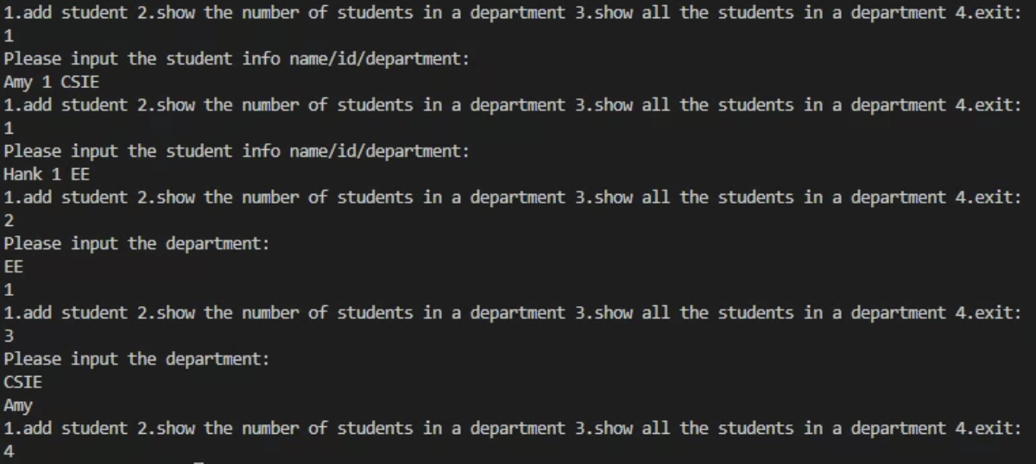

**例二：**

# input自此始，但不包括此行

2

CSIE

1

David 1 CSIE

2

CSIE

3

CSIE

1

Fread 2 CSIE

3

CSIE

4

# input至此止，但不包括此comment

# output自此始，但不包括此行

1.add student 2.show the number of students in a department 3.show all the students in a department 4.exit:

Please input the department:

0

1.add student 2.show the number of students in a department 3.show all the students in a department 4.exit:

Please input the student info name/id/department:

1.add student 2.show the number of students in a department 3.show all the students in a department 4.exit:

Please input the department:

1

1.add student 2.show the number of students in a department 3.show all the students in a department 4.exit:

Please input the department:

David

1.add student 2.show the number of students in a department 3.show all the students in a department 4.exit:

Please input the student info name/id/department:

1.add student 2.show the number of students in a department 3.show all the students in a department 4.exit:

Please input the department:

David

Fread

1.add student 2.show the number of students in a department 3.show all the students in a department 4.exit:

# output至此止，但不包括此comment

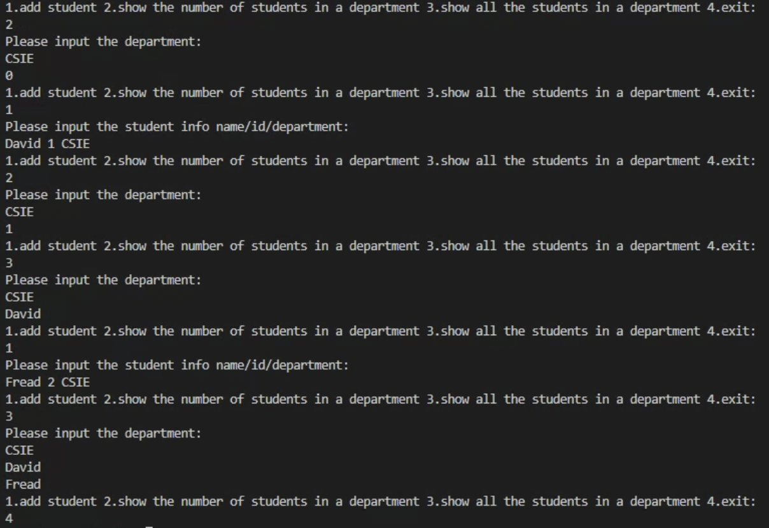

**評分標準：**

For each input (test data) file, your program must produce an output file with a content that is EXACTLY THE SAME AS the expected output. This is the only way your program can "pass" any particular test.

In general, we will use 5 test data to test your project. The total score of this project is 100 points, and each test data accounts for 20%.

**繳交格式：**

繳交方式、內容錯誤的斟酌扣分，完整作業格式詳見ee-class教材區「111-2 JAVA作業繳交及評分標準.pptx 」。若對作業有疑問，請上Discord留言或詢問助教，如有作業勘誤會於ee-class公告區或DC公告版公告，請自行留意。